3.3.3.2 Special request advice September 2011

ECOREGION Barents and Greenland seas
SUBJECT Status and harvest potential of the Harp seal stocks in the Greenland Sea
and the White Sea/Barents Sea, and of the Hooded seal stock in the
Greenland Sea

Advice summary

The harp seal stocks in the Greenland Sea and the White Sea/Barents Sea are increasing, and advice using three catch scenarios is provided for both stocks. The hooded seal stock in the Greenland Sea is well below N_{lim} (equal to 30% of the largest estimated population size), and thus the ICES advice is that no catch be allowed from this stock.

Request

In September 2010 the Norwegian Royal Ministry of Fisheries and Coastal Affairs requested ICES to:

Assess the status and harvest potential of harp seal stocks in the Greenland Sea and White Sea/Barents Sea and of the hooded seal stocks in the Greenland Sea, and

Assess the impact on the harp seal stocks in the Greenland Sea and the White Sea/Barents Sea of an annual harvest of:

- Current harvest levels,
- Sustainable catches (defined as the fixed annual catches that stabilizes the future 1+ population),
- Catches that would reduce the population over a 10-year period in such a manner that it would remain above a level of 70% of current level with 80% probability.

ICES advice

The advice is structured as an update of relevant parts of the advice provided by ICES in 2008 (ICES, 2008a).

The request concerns three stocks of seals: Greenland Sea harp seals, White Sea/Barents Sea harp seals, and Greenland Sea hooded seals. The distribution of the stocks is shown in Figure 1.
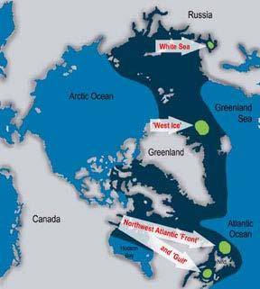

Figure 1 Locations of North Atlantic harp and hooded seal stocks. Green spots indicate the whelping and

moulting areas for the White Sea (also called the East Ice) stock of harp seals, the Greenland Sea
or West Ice stocks of harp and hooded seals (West Ice), and the northwest Atlantic stocks (Front
and Gulf areas) of harp and hooded seals. Dark blue indicates the entire distributional area.

ICES Advice 2011, Book 3 | 1

Greenland Sea harp seals

The estimated size of the Greenland Sea harp seal stock in 2011 is 649 570 (SE = 138 028) animals, comprising 553 100 (SE = 136 030) age 1+ seals, and 96 470 (SE = 23 401) young of the year. In 2011, the existing population model was modified to incorporate historical reproductive rate data. This resulted in a smaller stock than that reported in 2008. However, this revised estimate is still the largest in the time series. All model predictions indicate an increase in stock size of 1+ animals on a ten-year scale, with the 10-year increase ranging from 31% to 49%, assuming no harvesting or other unanticipated pressure.

The Greenland Sea harp seal stock is considered to be ‘data-rich’ and above the N₇₀ level (i.e., more than 70% of the known maximum stock size measured). Thus, it is appropriate to provide catch advice using the assessment model.

The analysis of catch options indicates the following:

- If the recent average catch (2007–2011) of 6 388 animals (63.4% pups) is maintained, the stock is expected to increase by 23% over 10 years.

- Sustainable catches are 25 410 animals (of which 63.4% are pups) or 16 737 (100% 1+ animals).

- Annual catches that would reduce the population over a 10-year period but would still maintain the stock above 70% of the current level with 80% probability are 35 000 animals (of which 63.4% are pups) or 25 000 (100% 1+ animals).

ICES regards 70% of the unexploited population size as the stock size associated with the maximum sustainable long-term average catch. This stock size (N₇₀) is estimated at 454,699 animals. The maximum sustainable long-term average catch is about 25 000 animals (of which 63.4% are pups) annually.

The current size of the Greeland Sea harp seal stock (i.e., 649 570 animals) is a record-high. Therefore N_{lim} (equal to 30% of the largest estimated population size) is estimated as 194 871 animals. ICES advises that this estimate of N_{lim} be regarded as the minimum sustainable size of the Greenland Sea harp seal stock. At or below this stock size, ICES recommends that there should be no catch.

White Sea/Barents Sea harp seals

The estimated size of the White Sea/Barents Sea stock is 1 364 700 animals (SE = 68 503). A recent survey estimated 163 032 (SE = 32 342) pups in the White Sea/Barents Sea , which is slightly higher than the estimates obtained from surveys conducted between 2005 (122 658; SE = 19 625) and 2009 (157 000; SE = 16 956). However, the recent pup estimate is considerably lower than survey estimates prior to 2004. The number of pups has substantially declined, presumably because of reduced reproductive rates.

The original population model for the White Sea/Barents Sea harp seal stock provides a poor fit to the pup production survey data. Incorporating fecundity data produced a lower estimate and a conservative projected population. Based on current data availability and the previously agreed criteria (three surveys within the past 15 years; one survey within the past five years; recent data on reproductive rates), the Barents Sea/White Sea harp seal stock is considered to be ‘data-rich’, and above the N₇₀ level. Catch advice is provided using the modified assessment model.

- If the recent average catch (2007–2011) of 5 056 animals ¹ (74.6% pups) is maintained, the stock is expected to increase by 11% over 10 years.
- Sustainable catches are 26 535 animals (of which 74.6% are pups) or 15 827 (100% 1+ animals).

- Annual catches that would reduce the population over a 10-year period but would still maintain the stock above 70% of the current level with 80% probability are 37 800 animals (of which 74.6% are pups) or 25 000 (100% 1+ animals)².

Greenland Sea hooded seals

The available historical data on pregnancy rates are unreliable. Hence, the assessment model was run using a range of pregnancy rates, in addition to a run using the original model assuming constant reproduction rates. All model runs indicate a current stock size well below N_{lim} of 233 700 animals (30% of the N_{max} estimate of 777 900 animals).

¹ It should be noted that the average catch in the last three years has been 105 animals.

2 ICES Advice 2011, Book 3
A population model, incorporating a reproduction rate of F = 0.9, produced a 2011 stock estimate of 67 770 1+ animals and 18 040 pups. The estimated total stock size of hooded seals in the Greenland Sea is therefore 85 810 animals (SE =
- 981).

  - Following the precautionary harvest strategy previously developed by ICES (see ICES, 2006a) and given that the current stock size of 85 810 animals is well below N_{lim} (233 700 animals), ICES recommends that no harvest be allowed from the Greenland Sea hooded seal stock.

Background

Greenland Sea harp seals

State of stock/exploitation

The adult population is at the highest level estimated in the historical time-series. Based on previous (1983–1991) mark–recapture data and recent (2002, 2007) aerial survey data, the stock in 2007 is estimated to be 649 566 (SE = 138 028) seals. The Greenland Seal harp seal stock is considered data rich, and above the N₇₀ level (i.e., more than 70% of the known maximum stock size measured).

The recent average annual catch (2007–2011) has been 6 388. The 2008 catches were 10 134 animals (including 5 361 pups) or 24% of the allocated quota of 42 225 seals. The quota has been implemented such that parts of, or the whole quota, could be taken as weaned pups, assuming two pups equaled one 1+ animal. Russia has not participated in this hunt since 1994.

Population estimates

Estimates of total population size are obtained from an age-structured model that incorporates information on reproduction (Tables 1 and 2) and catches (Table 3). In recent years catches have been much lower than the allocated quota (Table 4). The model is fitted to independent estimates of pup production (Table 5).

As suggested by ICES (2009), the model incorporates historical values of the reproductive rates (F) available from a Russian long-term data set and new Norwegian data from 2009 (Table 1). Hence, the pregnancy rate is no longer estimated, but considered a known quantity. In periods where data are missing, a linear transition between estimates is assumed. The proportion of mature females at age i, p_{i}, is no longer assumed to be constant for all years. The model utilizes two maturity curves; one for the period 1959 –1990 and the other for 2009 (Table 2). In the period 1990–2009, where data are missing, a linear transition between the two curves was assumed.

The estimated population sizes are presented in Table 6, along with the parameters for the normal priors used in the two model scenarios. The mean of the prior for M ₀ was taken to be three times that of the mean of M₁₊. The model estimates seem to be stable for various choices of precision of the prior of M₀ and M₁₊. Changes in the mean of the priors of M₀ and M₁₊ had little effect on the model estimates.

All model runs seem to indicate a substantial increase in population size from the 1970s up to the present time (Figure 2). The model which included time-varying reproductive rates provides a 25% lower population estimate than the original model. All model predictions indicate an increase in the stock size of 1+ animals over the next ten years, with increases ranging from 31% to 49%, assuming no hunt.

In the time- varying model, the 2011 stock size estimates are 553 100 1+ animals and 96 470 pups. The total 2011 stock size of harp seals in the Greenland Sea is estimated at 649 566 (95% C.I. = 379 031–920 101).

Catch options

ICES was requested to provide advice on the implications of various catch options for harp seals in the Greenland Sea:

The projected stock sizes at different catch options, using the new and modified population model, are given in Table 7. If current catch levels are maintained, a 23% increase of the stock size is projected over 10 years. Sustainable catches are 25 410 (63.4% pups) or 16 737 (100% 1+ animals). An annual catch level of 35 000 (assuming 63.4% pups) or 25 000 (assuming 100% 1+ animals) would reduce the stock over a 10-year period such that the stock remains above 70% of the current level with 80% probability.

ICES Advice 2011, Book 3 | 3

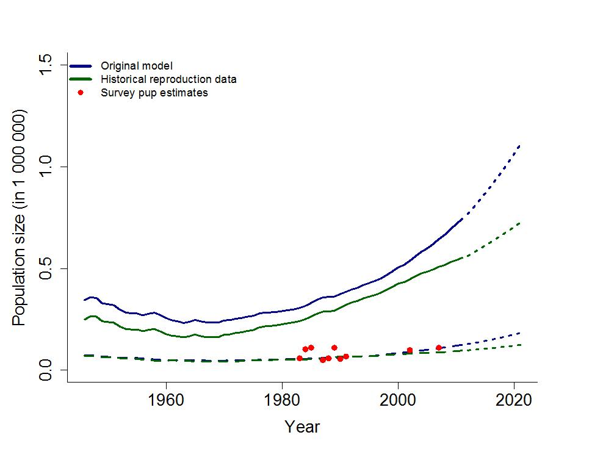

Figure 2 |  |  | Greenland Sea harp seals: Estimated model trajectories for various reproduction rates. Full lines
 |  |  | show 1+ abundance, dashed-dotted lines show pup abundances, and dashed lines show predictions
 |  |  | from the original and the time-varying models. Red dots are estimated pup production.
Table 1 |  |  | Reproduction rates, F_{t}, for harp seals in the Greenland Sea.
 |  |  |  |  | Year | Pregnancy rate |  |  |  | Standard
 |  |  |  |  |  |  |  |  |  | Deviation
 |  |  |  |  | 1964 | 0.92 |  |  |  | 0.04
 |  |  |  |  | 1978 | 0.88 |  |  |  | 0.03
 |  |  |  |  | 1987 | 0.78 |  |  |  | 0.03
 |  |  |  |  | 1990 | 0.86 |  |  |  | 0.04
 |  |  |  |  | 1991 | 0.83 |  |  |  | 0.05
 |  |  |  |  | 2008 | 0.80 |  |  |  | 0.06
 |  |  |  |  | 2009 | 0.81 |  |  |  | 0.03
Table 2 |  |  | Estimates of proportions of mature females (p_{i,t}). The P₁ |  |  |  |  |  |  |  |  |  | estimates are from the period 1959–1990
 |  |  | and the P₂ estimates are from 2009.
AGE | 1 | 2 |  | 3 | 4 | 5 | 6 |  | 7 |  | 8 |  | 9 |  | 10 | 11 | 12 | 13
P₁ | 0 | 0 |  | 0.06 | 0.29 | 0.55 | 0.74 |  | 0.86 |  | 0.93 |  | 0.96 |  | 0.98 | 0.99 | 1.00 | 1.00
P₂ | 0 | 0 |  | 0 | 0 | 0.06 | 0.28 |  | 0.55 |  | 0.76 |  | 0.88 |  | 0.95 | 0.98 | 0.99 | 1.00

4 ICES Advice 2011, Book 3
Table 3 | Catches of harp seals in the Greenland Sea (“West Ice”) from 1946 through 2011ª. Totals include
 | catches for scientific purposes.
Year | Norwegian catches |  |  |  | Russian catches |  |  |  | Total catches
 | Pups | 1 year | Total |  | pups | 1 year | Total | Pups | 1 year | Total
 |  | and older |  |  |  | and older |  |  | and older
1946–50 | 26606 | 9464 |  | 36070 | - | - | - | 26606 | 9464 | 36070
1951–55 | 30465 | 9125 |  | 39590 | - | - | ₋b | 30465 | 9125 | 39590
1956–60 | 18887 | 6171 |  | 25058 | 1148 | 1217 | 2365^{b} | 20035 | 7388 | 27423
1961–65 | 15477 | 3143 |  | 18620 | 2752 | 1898 | 4650 | 18229 | 5041 | 23270
1966–70 | 16817 | 1641 |  | 18458 | 1 | 47 | 48 | 16818 | 1688 | 18506
1971 | 11149 | 0 |  | 11149 | - | - | - | 11149 | 0 | 11149
1972 | 15100 | 82 |  | 15182 | - | - | - | 15100 | 82 | 15182
1973 | 11858 | 0 |  | 11858 | - | - | - | 11858 | 0 | 11858
1974 | 14628 | 74 |  | 14702 | - | - | - | 14628 | 74 | 14702
1975 | 3742 | 1080 |  | 4822 | 239 | 0 | 239 | 3981 | 1080 | 5061
1976 | 7019 | 5249 |  | 12268 | 253 | 34 | 287 | 7272 | 5283 | 12555
1977 | 13305 | 1541 |  | 14846 | 2000 | 252 | 2252 | 15305 | 1793 | 17098
1978 | 14424 | 57 |  | 14481 | 2000 | 0 | 2000 | 16424 | 57 | 16481
1979 | 11947 | 889 |  | 12836 | 2424 | 0 | 2424 | 14371 | 889 | 15260
1980 | 2336 | 7647 |  | 9983 | 3000 | 539 | 3539 | 5336 | 8186 | 13522
1981 | 8932 | 2850 |  | 11782 | 3693 | 0 | 3693 | 12625 | 2850 | 15475
1982 | 6602 | 3090 |  | 9692 | 1961 | 243 | 2204 | 8563 | 3333 | 11896
1983 | 742 | 2576 |  | 3318 | 4263 | 0 | 4263 | 5005 | 2576 | 7581
1984 | 199 | 1779 |  | 1978 | - | - | - | 199 | 1779 | 1978
1985 | 532 | 25 |  | 557 | 3 | 6 | 9 | 535 | 31 | 566
1986 | 15 | 6 |  | 21 | 4490 | 250 | 4740 | 4505 | 256 | 4761
1987 | 7961 | 3483 |  | 11444 | - | 3300 | 3300 | 7961 | 6783 | 14744
1988 | 4493 | 5170 |  | 9663^{c} | 7000 | 500 | 7500 | 11493 | 5670 | 17163
1989 | 37 | 4392 |  | 4429 | - | - | - | 37 | 4392 | 4429
1990 | 26 | 5482 |  | 5508 | 0 | 784 | 784 | 26 | 6266 | 6292
1991 | 0 | 4867 |  | 4867 | 500 | 1328 | 1828 | 500 | 6195 | 6695
1992 | 0 | 7750 |  | 7750 | 590 | 1293 | 1883 | 590 | 9043 | 9633
1993 | 0 | 3520 |  | 3520 | - | - | - | 0 | 3520 | 3520
1994 | 0 | 8121 |  | 8121 | 0 | 72 | 72 | 0 | 8193 | 8193
1995 | 317 | 7889 |  | 8206 | - | - | - | 317 | 7889 | 8206
1996 | 5649 | 778 |  | 6427 | - | - | - | 5649 | 778 | 6427
1997 | 1962 | 199 |  | 2161 | - | - | - | 1962 | 199 | 2161
1998 | 1707 | 177 |  | 1884 | - | - | - | 1707 | 177 | 1884
1999 | 608 | 195 |  | 803 | - | - | - | 608 | 195 | 803
2000 | 6328 | 6015 |  | 12343 | - | - | - | 6328 | 6015 | 12343
2001 | 2267 | 725 |  | 2992 | - | - | - | 2267 | 725 | 2992
2002 | 1118 | 114 |  | 1232 | - | - | - | 1118 | 114 | 1232
2003 | 161 | 2116 |  | 2277 |  |  |  | 161 | 2116 | 2277
2004 | 8288 | 1607 |  | 9895 |  |  |  | 8288 | 1607 | 9895
2005 | 4680 | 2525 |  | 7205 |  |  |  | 4680 | 2525 | 7205
2006 | 2343 | 961 |  | 3304 |  |  |  | 2343 | 961 | 3304
2007 | 6188 | 1640 |  | 7828 |  |  |  | 6188 | 1640 | 7828
2008 | 744 | 519 |  | 1263 |  |  |  | 744 | 519 | 1263
2009 | 5177 | 2918 |  | 8035 |  |  |  | 5177 | 2918 | 8035
2010 | 2823 | 1855 |  | 4678 |  |  |  | 2823 | 1855 | 4678
2011 | 5361 | 4773 |  | 10134 |  |  |  | 5361 | 4773 | 10134
- The period 1946–1970 shows only 5-year averages.

- For 1955, 1956, and 1957 Soviet catches of harp and hooded seals were reported at 3900, 11,600 and 12,900, respectively. These catches are not included.

- Including 1431 pups and one adult caught by a ship which was lost.

ICES Advice 2011, Book 3 | 5
 | Table 4 |  |  | Summaries of Norwegian harp and hooded sealing regulations¹ for the Greenland Sea (“West
 |  |  |  | Ice”), 1985–2011.
 | Year |  | Opening |  | Closing |  |  | Quotas |  |  |  | Allocations
 | Year |  |  |  |  |  |  |  |  |  |  |  | Soviet &
 | Year |  | Date |  | Date |  | Total | Pups |  | Female | Male | Norway | Soviet &
 |  |  |  |  |  |  |  |  |  | Female | Male | Norway | Russia
 | Hooded Seals
1985 |  |  | 22 | March | 5 May |  | (20,000)² | (20,000)² |  | ₀3 | Unlim. | 8,000⁴ | 3,300
1986 |  |  | 18 | March | 5 May |  | 9,300 | 9,300 |  | ₀3 | Unlim. | 6,000 | 3,300
1987 |  |  | 18 | March | 5 May |  | 20,000 | 20,000 |  | ₀3 | Unlim. | 16,700 | 3,300
1988 |  |  | 18 | March | 5 May |  | (20,000)² | (20,000)² |  | ₀3 | Unlim. | 16,700 | 5,000
1989 |  |  | 18 | March | 5 May |  | 30,000 | 0 |  | ₀3 | Incl. | 23,100 | 6,900
1990 |  |  | 26 | March | 30 | June | 27,500 | 0 |  | 0 | Incl. | 19,500 | 8,000
1991 |  |  | 26 | March | 30 | June | 9,000 | 0 |  | 0 | Incl. | 1,000 | 8,000
 | 1992–94 |  | 26 | March | 30 | June | 9,000 | 0 |  | 0 | Incl. | 1,700 | 7,300
1995 |  |  | 26 | March | 10 | July | 9,000 | 0 |  | 0 | Incl. | 1,700⁷ | 7,300
1996 |  |  | 22 | March | 10 | July | 9,000⁸ |  |  |  |  | 1,700 | 7,300
 | 1997 |  | 26 | March | 10 | July | 9,000⁹ |  |  |  |  | 6,200 | 2,800¹¹
 | 1998 |  | 22 | March | 10 | July | 5,000¹⁰ |  |  |  |  | 2,200 | 2,800¹¹
 | 1999–00 |  | 22 | March | 10 | July | 11,200¹² |  |  |  |  | 8,400 | 2,800¹¹
 | 2001–03 |  | 22 | March | 10 | July | 10,300¹² |  |  |  |  | 10,300
 | 2004–05 |  | 22 | March | 10 | July | 5,600¹² |  |  |  |  | 5,600
 | 2006 |  | 22 | March | 10 | July | 4,000 |  |  |  |  | 4,000
 | 2007–11¹⁴ |  |  |  |  |  | 0 | 0 |  | 0 | 0 | 0 | 0
 | Harp Seals
 | 1985 |  | 10 | April | 5 May |  | (25,000)² | (25,000)² |  | 0⁵ | 0⁵ | 7,000 | 4,500
 | 1986 |  | 22 | March | 5 May |  | 11,500 | 11,500 |  | 0⁵ | 0⁵ | 7,000 | 4,500
 | 1987 |  | 18 | March | 5 May |  | 25,000 | 25,000 |  | 0⁵ | 0⁵ | 20,500 | 4,500
 | 1988 |  | 10 | April | 5 May |  | 28,000 | ₀5,6 |  | ₀5,6 | ₀5,6 | 21,000 | 7,000
 | 1989 |  | 18 | March | 5 May |  | 16,000 | - |  | 0⁵ | 0⁵ | 12,000 | 9,000
 | 1990 |  | 10 | April | 20 | May | 7,200 | 0 |  | 0⁵ | 0⁵ | 5,400 | 1,800
 | 1991 |  | 10 | April | 31 | May | 7,200 | 0 |  | 0⁵ | 0⁵ | 5,400 | 1,800
 | 1992–93 |  | 10 | April | 31 | May | 10,900 | 0 |  | 0⁵ | 0⁵ | 8,400 | 2,500
 | 1994 |  | 10 | April | 31 | May | 13,100 | 0 |  | 0⁵ | 0⁵ | 10,600 | 2,500
 | 1995 |  | 10 | April | 31 | May | 13,100 | 0 |  | 0⁵ | 0⁵ | 10,600⁷ | 2,500
 | 1996 |  | 10 | April | 31 | May⁸ | 13,100⁹ |  |  |  |  | 10,600 | 2,500¹¹
 | 1997–98 |  | 10 | April | 31 | May | 13,100¹⁰ |  |  |  |  | 10,600 | 2,500¹¹
 | 1999–00 |  | 10 | April | 31 | May | 17,500¹³ |  |  |  |  | 15,000 | 2,500¹¹
 | 2001–05 |  | 10 | April | 31 | May | 15,000¹³ |  |  |  |  | 15,000 | 0
 | 2006–07 |  | 10 | April | 31 | May | 31,200 |  |  |  |  | 31,200 | 0
 | 2008 |  | 5 April |  | 31 | May | 31,200 |  |  |  |  | 31,200 | 0
 | 2009 |  | 10 | April | 31 | May | 40,000 |  |  |  |  | 40,000 | 0
 | 2010 |  | 10 | April | 31 | May | 42,000 |  |  |  |  | 42,000 | 0
 | 2011 |  | 10 | April | 31 | May | 42,000 |  |  |  |  | 42,000 | 0

- Other regulations include: Prescriptions for date of departure from Norwegian port; only one trip per season; licensing; killing methods; and inspection.
- Basis for allocation of USSR quota.

- Breeding females protected; for safety reasons two pups are deducted from the quota for each female taken.
- Adult males only.

- 1 year+ seals protected until 9 April; pup quota may be filled by 1 year+ after 10 April.

- Any age or sex group.

- Included 750 weaned pups under permit for scientific purposes.

- Pups allowed to be taken from 26 March to 5 May.

- Half the quota could be taken as weaned pups, where two pups equalled one 1+ animal.
- The whole quota could be taken as weaned pups, where two pups equalled one 1+ animal.

- Russian allocation reverted to Norway.

- Quota given in 1+ animals, parts of or the whole quota could be taken as weaned pups, where 1.5 pups equalled one 1+ animal.
- Quota given in 1+ animals, parts of or the whole quota could be taken as weaned pups, where 2 pups equalled one 1+ animal.

- Hooded seals protected, small takes are allowed for scientific purposes only.

6 ICES Advice 2011, Book 3
Table 5 | Survey estimates of Greenland Sea harp seal pup production.
 |  | YEAR | ESTIMATE | C.V.
 |  | 1983 | 58,539 | 0.10
 |  | 1984 | 103,250 | 0.15
 |  | 1985 | 111,084 | 0.20
 |  | 1987 | 49,970 | 0.08
 |  | 1988 | 58,697 | 0.18
 |  | 1989 | 110,614 | 0.08
 |  | 1990 | 55,625 | 0.08
 |  | 1991 | 67,271 | 0.08
 |  | 2002 | 98,500 | 0.18
 |  | 2007 | 110,530 | 0.25

Table 6 | Greenland Sea harp seals: Model estimates and standard deviation of the parameters used in the
 | model for various choices of the reproduction rate F. Priors used are shown in brackets.
Parameters |  | Traditional NE model |  |  |  | Time-varying NE model
 |  | Mean |  | SE |  | Mean |  |  | SE
^{N}t₀ |  | 344 670 (900000) |  | 63 755 (900000) |  | 249 777 |  |  | 37 992
M₀ |  | 0.22 | (0.24) | 0.2 | (0.2) | 0.28 |  |  | 0.2
M1+ |  | 0.10 | (0.08) | 0.02 | (0.1) | 0.11 |  |  | 0.02
F |  | 0.79 | (0.81) | 0.02 | (0.2) | NA |  |  | NA
 |  | 124 800 |  | 24 922 |  | 96 470 |  |  | 23 401
 |  | 744 700 |  | 185 400 |  | 553 100 |  |  | 136 030
 |  | 869 500 |  | 187 068 |  | 649 570 |  |  | 138 028
Table 7 | Catch options with relative population size (D1+) and 95% confidence intervals over 10 years for
 | harp seals in the Greenland Sea. The model with historical reproduction parameters is used when
 | evaluating these catch options.
Option # | Catch level | Proportion of |  | Pup catch | 1+ catch | Total | D1+
 |  | pups | in |  |  | catch
 |  | catches |  |  |  |  | Lower | Point | Upper CI
 |  |  |  |  |  |  | CI
1 | Current | 63.4% |  | 4 046 | 2 341 | 6 387 | 0.92 | 1.23 | 1.54
 | harvest
2 | Sustainable | 63.4% |  | 16 110 | 9 300 | 25 410 | 0.61 | 1.00 | 1.40
 | harvest
3 | Sustainable | 0% |  | 0 | 16 737 | 16 737 | 0.65 | 1.02 | 1.40
 | harvest
5 | Reduce to N₇₀ | 63.4% |  | 22 190 | 12 810 | 35 000 | 0.45 | 0.89 | 1.32
6 | Reduce to N₇₀ | 0% |  | 0 | 25 000 | 25 000 | 0.46 | 0.88 | 1.31
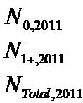

ICES Advice 2011, Book 3 | 7

White Sea/Barents Sea harp seals

State of stock/exploitation

Pup production in the White Sea/Barents Sea herd declined by approximately 50% between the 2004 and 2005 surveys. Pup production has remained low since then. Fitting the population model to the aerial survey data results in an estimated 2011 stock of 1 364 700 animals.

The average annual catch (2007–2011) has been 5056 animals, but catches have been much lower in the last three years, averaging 105 animals per year. This represents less than 1% of the quota allocated between Russia and Norway (45 100 and 10 000 seals, respectively). All of the 2010 harvest was taken by Norway.

Population estimates

Estimates of total population size are obtained from an age-structured model that incorporates information on reproduction (Tables 8 and 9) and catches (Table 10). In recent years catches have been much lower than the allocated quota (Table 11). The model is fitted to independent estimates of pup production (Table 12).

The model incorporates reproductive rates (F) as an input. Three approaches to incorporate reproductive rates into the model were examined.

- A constant maturity curve, p₄, and a constant pregnancy rate, F, estimated from the most recent reproductive sample from 2006 (see Tables 8 and 9).

- An adjusted model with time varying maturity curve, p_{i,t}, and a time-varying pregnancy rate, F_{t} (see Tables 8 and 9).The values used for the maturity curve are historical estimates and the latest estimate from 2006. Only four maturity curves are available. Where estimates were missing a linear interpolation was applied to estimate the maturity curve. A linear transition was also used for periods with missing pregnancy rates (i.e. a linear transition from 0.84 in 1990 to 0.68 in 2006). In the periods before 1990 the pregnancy rate was assumed constant at 0.84. In the periods after 2006 the pregnancy rate was assumed constant at 0.68.

- The pregnancy rate was assumed to be correlated with the condition of seals. This improved the fit of the model to the observed changes in pup production. But before this model can be used in the assessment further work is required to examine the functional relationship between changes in condition and changes in reproductive rates.

The estimated population sizes and the parameters for the normal priors used in the two first model scenarios are presented in Table 13. The mean of the prior for M₀ was taken to be three times that of the mean of M₁₊. The model estimates seem to be stable for various choices of precision of the priors of M₀ and M₁₊. Also changes in the mean of the priors of M₀ and M₁₊ did not affect the model estimates much.

Neither the original model nor the modified model using historical reproductive rate data were able to capture the observed survey pup production estimates properly. The model incorporating historical reproductive data provides a 2011 stock size of 1 172 000 (95% C.I. = 1 039 240–1 304 760) 1+ animals and 192 700 pups. The total estimated population is 1 364 700 (95% C.I. = 1 230 384–1 498 916) (Table 13; Figure 3).

Catch options

Based on current data availability and the criteria agreed to previously (three surveys within the past 15 years, one survey within the past five years, recent data on reproductive rates), the Barents Sea/White Sea harp seal stock is considered to be data rich and above the N₇₀ level (i.e. more than 70% of known maximum stock size measured). Catch advice is provided using the assessment model incorporating time-varying reproductive rates.

The estimates for the three requested catch options are given in Table 14. By incorporating the full range of reproductive data available, the model provides a new (and lower) estimate of the total population. The catch options provided are, therefore, also lower than the catch options estimated in 2009. At current catch levels a stock increase of about 11% is predicted over the next 10 years. Sustainable catches are 26 535 (of which 74.6% are pups) or 15 827 (100% 1+ animals). Annual catches of 37 800 (of which 74.6% are pups) or 25 000 (100% 1+ animals) over a 10-year

8 ICES Advice 2011, Book 3
period would reduce the stock such that the stock would remain above a level of 70% of the current level with 80% probability ².
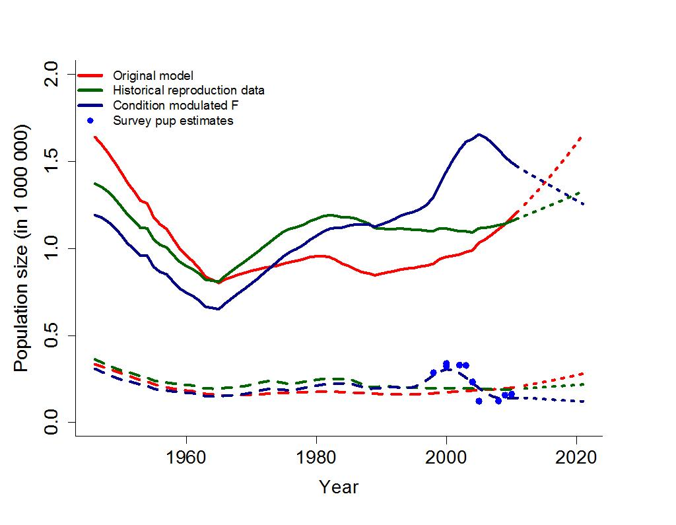

Figure 3 Modelling the Barents Sea/White Sea harp seal population: Population trajectories for pups

(dashed lines) and the 1+ population (full lines) for all three scenarios. The model with
reproduction varying with condition was examined, but further work is needed using this

approach, and additional results are not included here. The dotted lines show model predictions,
blue dots are survey pup production estimates.

Table 8 |  |  |  | Estimates of proportions of mature females (p) at ages 2–15 in four historical periods: P₁ = 1962–
 |  |  |  | 1972; P₂ = 1976–1985; P₃ = 1988–1993; and P₄ = 2006–2009.
 |  | Age | 2 | 3 | 4 | 5 | 6 | 7 | 8 | 9 | 10 | 11 | 12 | 13 | 14 | 15
 |  | P₁ | 0 | 0.01 | 0.17 | 0.64 | 0.90 | 0.98 | 0.99 | 1.0 | 1.0 | 1.0 | 1.0 | 1.0 | 1.0 | 1.0
 |  | P₂ | 0 | 0 | 0 | 0.24 | 0.62 | 0.81 | 0.81 | 0.95 | 0.98 | 0.99 | 0.99 | 1.0 | 1.0 | 1.0
 |  | P₃ | 0 | 0 | 0.02 | 0.08 | 0.21 | 0.40 | 0.59 | 0.75 | 0.85 | 0.91 | 0.95 | 0.97 | 0.98 | 0.99
 |  | P₄ | 0.01 | 0.02 | 0.05 | 0.11 | 0.25 | 0.55 | 0.90 | 0.99 | 1.0 | 1.0 | 1.0 | 1.0 | 1.0 | 1.0

Table 9 | Estimates of proportion of females giving birth.
 |  |  | Year | Estimated F
 |  |  | 1990–93 | 0.84
 |  | 2006 |  | 0.68

² Note that the White Sea/ Barents Sea stock is approximately double the size of the Greenland Sea stock. However, because fecundity is lower in the White Sea/Barents Sea, the catch advice is similar in both areas.

ICES Advice 2011, Book 3 | 9
 | Table 10 | Annual catches of harp seals in the White and Barents seas (“East Ice”), 1946–2008^{a,b}.
 | Year | Norwegian catches |  |  |  |  |  | Russian catches |  |  |  |  |  |  | Total catches
 |  | Pups |  | 1 year and |  | Total |  | Pups |  | 1 year and |  | Total |  | Pups |  | 1 year and |  | Total
 |  |  |  | older |  |  |  |  |  | older |  |  |  |  |  | older
 | 1946–50 |  |  |  | 25057 |  | 90031 |  | 55285 |  | 145316 |  |  |  |  |  | 170373
 | 1951–55 |  |  |  | 19590 |  | 59190 |  | 65463 |  | 124653 |  |  |  |  |  | 144243
 | 1956–60 | 2278 | 14093 |  | 16371 |  | 58824 |  | 34605 |  | 93429 |  | 61102 |  | 48698 |  | 109800
 | 1961–65 | 2456 | 8311 |  | 10767 |  | 46293 |  | 22875 |  | 69168 |  | 48749 |  | 31186 |  | 79935
 | 1966–70 |  |  |  | 12783 |  | 21186 |  | 410 |  | 21596 |  |  |  |  |  | 34379
 | 1971 | 7028 |  | 1596 |  | 8624 |  | 26666 |  | 1002 |  | 27668 |  | 33694 |  | 2598 |  | 36292
1972 |  | 4229 | 8209 |  | 12438 |  | 30635 |  | 500 |  | 31135 |  | 34864 |  | 8709 |  | 43573
1973 |  | 5657 | 6661 |  | 12318 |  | 29950 |  | 813 |  | 30763 |  | 35607 |  | 7474 |  | 43081
1974 |  | 2323 | 5054 |  | 7377 |  | 29006 |  | 500 |  | 29506 |  | 31329 |  | 5554 |  | 36883
1975 |  | 2255 | 8692 |  | 10947 |  | 29000 |  | 500 |  | 29500 |  | 31255 |  | 9192 |  | 40447
1976 |  | 6742 | 6375 |  | 13117 |  | 29050 |  | 498 |  | 29548 |  | 35792 |  | 6873 |  | 42665
1977 |  | 3429 | 2783 |  |  | 6212^{c} | 34007 |  | 1488 |  | 35495 |  | 37436 |  | 4271 |  | 41707
1978 |  | 1693 | 3109 |  | 4802 |  | 30548 |  | 994 |  | 31542 |  | 32341 |  | 4103 |  | 36344
1979 |  | 1326 | 12205 |  | 13531 |  | 34000 |  | 1000 |  | 35000 |  | 35326 |  | 13205 |  | 48531
1980 |  | 13894 | 1308 |  | 15202 |  | 34500 |  | 2000 |  | 36500 |  | 48394 |  | 3308 |  | 51702
1981 |  | 2304 | 15161 |  |  | 17465^{d} | 39700 |  | 3866 |  | 43566 |  | 42004 |  | 19027 |  | 61031
1982 |  | 6090 | 11366 |  | 17456 |  | 48504 |  | 10000 |  | 58504 |  | 54594 |  | 21366 |  | 75960
1983 |  | 431 | 17658 |  | 18089 |  | 54000 |  | 10000 |  | 64000 |  | 54431 |  | 27658 |  | 82089
1984 |  | 2091 | 6785 |  | 8876 |  | 58153 |  | 6942 |  | 65095 |  | 60244 |  | 13727 |  | 73971
1985 |  | 348 | 18659 |  | 19007 |  | 52000 |  | 9043 |  | 61043 |  | 52348 |  | 27702 |  | 80050
1986 |  | 12859 | 6158 |  | 19017 |  | 53000 |  | 8132 |  | 61132 |  | 65859 |  | 14290 |  | 80149
1987 |  | 12 | 18988 |  | 19000 |  | 42400 |  | 3397 |  | 45797 |  | 42412 |  | 22385 |  | 64797
1988 |  | 18 | 16580 |  | 16598 |  | 51990 |  |  | 2501e | 54401 |  | 51918 |  | 19081 |  | 70999
1989 |  | 0 | 9413 |  | 9413 |  | 30989 |  | 2475 |  | 33464 |  | 30989 |  | 11888 |  | 42877
1990 |  | 0 | 9522 |  | 9522 |  | 30500 |  | 1957 |  | 32457 |  | 30500 |  | 11479 |  | 41979
1991 |  | 0 | 9500 |  | 9500 |  | 30500 |  | 1980 |  | 32480 |  | 30500 |  | 11480 |  | 41980
1992 |  | 0 | 5571 |  | 5571 |  | 28351 |  | 2739 |  | 31090 |  | 28351 |  | 8310 |  | 36661
1993 |  | 0 |  | 8758^{f} | 8758 |  | 31000 |  | 500 |  | 31500 |  | 31000 |  | 9258 |  | 40258
1994 |  | 0 | 9500 |  | 9500 |  | 30500 |  | 2000 |  | 32500 |  | 30500 |  | 11500 |  | 42000
1995 |  | 260 | 6582 |  | 6842 |  | 29144 |  | 500 |  | 29644 |  | 29404 |  | 7082 |  | 36486
1996 |  | 2910 | 6611 |  | 9521 |  | 31000 |  | 528 |  | 31528 |  | 33910 |  | 7139 |  | 41049
1997 |  | 15 | 5004 |  | 5019 |  | 31319 |  | 61 |  | 31380 |  | 31334 |  | 5065 |  | 36399
1998 |  | 18 | 814 |  | 832 |  | 13350 |  | 20 |  | 13370 |  | 13368 |  | 834 |  | 14202
1999 |  | 173 | 977 |  | 1150 |  | 34850 |  | 0 |  | 34850 |  | 35023 |  | 977 |  | 36000
2000 |  | 2253 | 4104 |  | 6357 |  | 38302 |  | 111 |  | 38413 |  | 40555 |  | 4215 |  | 44770
2001 |  | 330 | 4870 |  | 5200 |  | 39111 |  | 5 |  | 39116 |  | 39441 |  | 4875 |  | 44316
2002 |  | 411 | 1937 |  | 2348 |  | 34187 |  | 0 |  | 34187 |  | 34598 |  | 1937 |  | 36535
2003 |  | 2343 | 2955 |  | 5298 |  | 37936 |  | 0 |  | 37936 |  | 40279 |  | 2955 |  | 43234
2004 |  | 0 | 33 |  | 33 |  | 0 |  | 0 |  | 0 |  | 0 |  | 33 |  | 33
2005 |  | 1162 | 7035 |  | 8197 |  | 14258 |  | 19 |  | 14277 |  | 15488 |  | 9405 |  | 22474
2006 |  | 147 | 9939 |  | 10086 |  | 7005 |  | 102 |  | 7107 |  | 7152 |  | 10041 |  | 17193
2007 |  | 242 | 5911 |  | 6153 |  | 5276 |  | 200 |  | 5476 |  | 5518 |  | 6111 |  | 11629
2008 |  | 0 | 0 |  | 0 |  | 13331 |  | 0 |  | 13331 |  | 13331 |  | 0 |  | 13331
2009 |  | 0 | 0 |  | 0 |  | 0 |  | 0 |  | 0 |  | 0 |  | 0 |  | 0
2010 |  | 0 | 105 |  | 105 |  | 5 |  | 5 |  | 10 |  | 5 |  | 110 |  | 115
2011 |  | 0 | 200 |  | 200 |  | 0 |  | 0 |  | 0 |  | 0 |  | 200 |  | 200

- The period 1946–1970 shows only 5-year averages.

- Incidental catches of harp seals in fishing gear on Norwegian and Murmansk coasts are not included.

- Approx. 1300 harp seals (unspecified age) caught by a ship which was lost are not included.
- An additional 250–300 animals were shot but lost as they drifted into Soviet territorial waters.

- Russian catches of 1+ animals after 1987 selected by scientific sampling protocols.

- Included 717 seals caught to the south of Spitsbergen, east of 14°E, by a ship operating mainly in the Greenland Sea.

10 ICES Advice 2011, Book 3
Table 11 | Summary of sealing regulations for the White and Barents seas (“East Ice”) harp seals, 1979–
 | 2011.
Year | Opening dates |  | Closing date |  | Quota allocation
Year | Soviet/Rus. | Norway | Closing date | Total |  | Soviet/Rus. |  | Norway
1979–80 | 1 March | 23 March | 30 April¹ | 50,000² |  | 34,000 |  | 16,000
1981 | - | - | - | 60,000 |  | 42,500 |  | 17,500
1982 | - | - | - | 75,000 |  | 57,500 |  | 17,500
1983 | - | - | - | 82,000 |  | 64,000 |  | 18,000
1984 | - | - | - | 80,000 |  | 62,000 |  | 18,000
1985–86 | - | - | - | 80,000 |  | 61,000 |  | 19,000
1987 | - | - | 20 April¹ | 80,000 |  | 61,000 |  | 19,000
1988 | - | - | - | 70,000 |  | 53,400 |  | 16,600
1989–94 | - | - | - | 40,000 |  | 30,500 |  | 9,500
1995 | - | - | - | 40,000 |  | 31,250 |  | 8,750³
1996 | - | - | - | 40,000 |  | 30,500 |  | 9,500
1997–98 | - | - | - | 40,000 |  | 35,000 |  | 5,000
1999 | - | - | - | 21,400⁴ |  | 16,400 |  | 5,000
2000 | 27 February | - | - | 27,700⁴ |  | 22,700 |  | 5,000
2001–02 | - | - | - | 53,000⁴ |  | 48,000 |  | 5,000
2003 | - | - | - | 53,000⁴ |  | 43,000 |  | 10,000
2004–05 |  |  |  | 45,100⁴ |  | 35,100 |  | 10,000
2006 | - | - | - | 78,200⁴ |  | 68,200 |  | 10,000
2007 | - | - | - | 78,200⁴ |  | 63,200 |  | 15,000
2008 | - | - | - | 55,100⁴ |  | 45,100 |  | 10,000
2009 | - | - | - | 35,000 |  | 28,000 |  | 7,000
2010 |  |  |  | 7,000 |  | 0 |  | 7,000
2011 |  |  |  | 7,000 |  | 0 |  | 7,000

- The closing date may be postponed until 10 May if necessitated by weather or ice conditions.
- Breeding females protected (all years).

- Included 750 weaned pups under permit for scientific purposes.

- Quotas given in 1+ animals; parts of or the whole quota could be taken as pups, where 2.5 pups equal one 1+ animal.

Table 12 |  | Timing of Russian surveys, estimated numbers of pups, and coefficients of variation (CV) in the
 |  | White Sea/Barents Sea.
 | Year |  | Survey period |  |  | Estimated number | Coefficient of
 |  |  |  |  |  | of pups | variation
 | 1998 |  | 12 | & 16 March |  | 286,260 | 0.150
 | 2000 |  | 10–12 |  | March – photo | 322,474ª | 0.098
 |  |  | 18 | March – multispectral |  | 339,710^{b} | 0.105
 | 2002 |  | 20 | March |  | 330,000 | 0.103
 | 2003 |  | 18 | & 21 March |  | 328,000^{c} | 0.181
 | 2004 |  | 22 | March – photo |  | 231,811 | 0.190
 |  |  | 22 | March – multispectral |  | 234,000 | 0.205
 | 2005 |  | 23 | March |  | 122,658 | 0.162
 | 2008 |  | 19–20 |  | March | 123,104 | 0.199
 | 2009 |  | 14–16 |  | March | 157,000 | 0.108
 | 2010 |  | 20–23 |  | March | 163,032 | 0.198

- The first 2000 estimate is the sum of 291 745 pups (SE = 28 708) counted plus a catch of 30 729 prior to the survey, leading to a total pup production of 322 474.
- The second 2000 estimate is the sum of 308 981 pups (SE = 32 400) counted plus a catch of 30 729 prior to the survey, leading to a total pup production of 339 710.
- The 2003 estimate is the sum of 298 000 pups (SE = 53 000) counted plus a catch of 35 000 prior to the survey, leading to a total pup production of 328 000.

ICES Advice 2011, Book 3 | 11
Table 13 | Barents Sea/White Sea harp seals: Model estimates and standard deviation of the parameters used
 | in the model for various choices of the reproduction rate F. Priors used are shown in brackets.
 | Traditional model |  | Time-varying model |  | Model with historical values
Parameters |  |  |  |  | of p_{i,t} and condition modelled
Parameters |  |  |  |  | Ft
 | Mean | SE | Mean | SE | Mean | SE
^{N}t₀ | 1 639 253 | 128 090 | 1 372 033 | 122 590 | 1 181 366 | 105 220
^{N}t₀ | (1 000 000) | (200 000)
M0 | 0.33 | 0.05 | 0.35 | 0.05 | 0.30 | 0.05
M1+ | (0.30) | (0.05)
M1+ | 0.10 | 0.03 | 0.11 | 0.01 | 0.09 | 0.01
 | (0.09) | (0.008)
 | 205 000 | 10 785 | 192 700 | 10 216 | 142 700 | 8 879
 | 1 212 000 | 70 029 | 1 172 000 | 67 737 | 1 485 000 | 97 722
 | 1 417 000 | 70 855 | 1 364 700 | 68 503 | 1 627 700 | 98 125

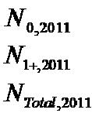

Table 14 | Catch options with relative population size (D1+) in 2021 for harp seals in the Barents Sea/White
 | Sea.
Option # | Catch level | Proportion | Pup | 1+ | Total catch | D1+
 |  | of pups in | catch | catch
 |  | catches |  |  |  | Lower | Point | Upper CI
 |  |  |  |  |  | CI
1 | Current | 74.6% | 3 771 | 1 285 | 5 056 | 1.00 | 1.11 | 1.23
2 | Sustainable | 74.6% | 19 795 | 6 740 | 26 535 | 0.89 | 1.00 | 1.12
3 | Sustainable | 0% | 0 | 15 827 | 15 827 | 0.90 | 1.01 | 1.13
5 | Reduce to N₇₀ª | 74.6% | 28 199 | 9 601 | 37 800 | 0.83 | 0.95 | 1.06
6 | Reduce to N₇₀ª | 0% | 0 | 25 000 | 25 000 | 0.84 | 0.95 | 1.06

12 ICES Advice 2011, Book 3
Greenland Sea hooded seals

State of stock/exploitation

Concerns over low pup production estimates resulted in advice from ICES that no harvest of Greenland Sea hooded seals should be permitted, with the exception of catches for scientific purposes, from 2007 on (ICES, 2006b). This advice was immediately implemented.

Results from the 2007 pup survey suggest that pup production (16 140 pups, CV = 0.13) remains low and was significantly lower than observed in the 1997 survey (24 000 pups, CV = 0.28) . Model explorations indicate a substantial decrease in stock size from the late 1940s and up to the early 1980s. The results suggest that the stock may have stabilized at a low level over the past 20 years, but the current trajectory remains uncertain.

The stock is estimated to be well below N_{lim}. As a result, ICES recommended in 2008 (ICES, 2008a) that there be no catch of Greenland Sea hooded seals. There was no catch in 2007–2008. ICES continues to advise that there shall be no catch of Greenland Sea hooded seals.

Population estimates

The population model used to assess the stock size is an age-structured population dynamics model. The model is similar to the model assessing the stock of the Barents Sea/White Sea harp seal population and has been modified to incorporate historical maturity curves and historical pregnancy rates (Table 15). The available data on pregnancy rates are unreliable. Hence, the model was run for a range of pregnancy rates. All runs indicate a population currently well below N_{lim} of 233 700 (30% of the N_{max} estimate of 777 900).

The model incorporates catches into the model structure (Table 16) . In recent years there have been no catches except for the removal of animals for scientific reasons (Table 4). The model is fitted to independent estimates of pup production to estimate the current total population (Table 17).

The model incorporated the only measured historical reproductive rate which consists of one estimate from the 1990s. Consequently, the model was run for a range of pregnancy rates. In addition to a run using the original model assuming constant reproductive rates, three additional scenarios, with F = 0.5, F = 0.7, and F = 0.9 were also run. The estimated population sizes, along with the parameters for the normal priors used in the model scenarios, are presented in Table 18. The mean of the prior for M₀ was taken to be three times that of the mean of M₁₊. The model estimates seem to be stable for various choices of precision of the priors of M₀ and M₁₊. Also, changes in the mean of the prior of M₀ and M₁₊ did not affect the model estimates much.

Using a reproduction rate of F = 0.9, the 2011 stock estimates of 67 770 1+ animals and 18 040 pups are obtained. The total 2011 stock of hooded seals in the Greenland Sea is estimated at 85 810 (95% C.I. = 58 407–113 212) seals of all ages (Figure 4 ).

Catch options

The Greenland Sea hooded seal stock in 2007 was well below N_{lim}. It is recommended that no harvest be allowed for Greenland Sea hooded seals at this time.

ICES Advice 2011, Book 3 | 13

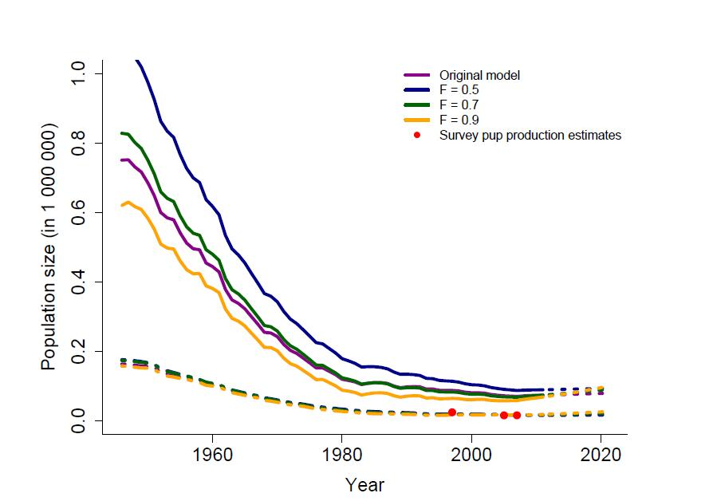

Figure 4 Greenland Sea hooded seals: Estimated model trajectories for various model scenarios. Full lines

show 1+ abundance, dashed-dotted lines show pup abundances, and dashed lines show model
predictions. Red dots are results from aerial pup production estimations.

Table 15 |  | Estimates of proportions of mature females (p_{i,t}). The P₁ estimates are from data collected in 1990–
 |  | 1994 and the P₂ estimates are from 2008 and 2010.
 | Age | 1 | 2 | 3 | 4 | 5 | 6 | 7 | 8 | 9 | 10 | 11
 | P₁ | 0 | 0.05 | 0.27 | 0.54 | 0.75 | 0.87 | 0.93 | 0.97 | 0.98 | 0.99 | 1.00
 | P2 | 0.02 | 0.11 | 0.45 | 0.82 | 0.95 | 0.99 | 1.00 | 1.00 | 1.00 | 1.00 | 1.00

14 ICES Advice 2011, Book 3
Table 16 | Catches of hooded seals in the Greenland Sea (“West Ice”) from 1946 through 2008ª. Totals
 | include catches for scientific purposes.
Year | Norwegian catches |  |  | Russian catches |  |  |  | Total catches
 | Pups | 1 year | Total | Pups | 1 year | total | Pups | 1 year | Total
 |  | and older |  |  | and older |  |  | and older
1946–50 | 31152 | 10257 | 41409 | - | - | - | 31152 | 10257 | 41409
1951–55 | 37207 | 17222 | 54429 | - | - | ₋b | 37207 | 17222 | 54429
1956–60 | 26738 | 9601 | 36339 | 825 | 1063 | 1888^{b} | 27563 | 10664 | 38227
1961–65 | 27793 | 14074 | 41867 | 2143 | 2794 | 4937 | 29936 | 16868 | 46804
1966–70 | 21495 | 9769 | 31264 | 160 | 62 | 222 | 21655 | 9831 | 31486
1971 | 19572 | 10678 | 30250 | - | - | - | 19572 | 10678 | 30250
1972 | 16052 | 4164 | 20216 | - | - | - | 16052 | 4164 | 20216
1973 | 22455 | 3994 | 26449 | - | - | - | 22455 | 3994 | 26449
1974 | 16595 | 9800 | 26395 | - | - | - | 16595 | 9800 | 26395
1975 | 18273 | 7683 | 25956 | 632 | 607 | 1239 | 18905 | 8290 | 27195
1976 | 4632 | 2271 | 6903 | 199 | 194 | 393 | 4831 | 2465 | 7296
1977 | 11626 | 3744 | 15370 | 2572 | 891 | 3463 | 14198 | 4635 | 18833
1978 | 13899 | 2144 | 16043 | 2457 | 536 | 2993 | 16356 | 2680 | 19036
1979 | 16147 | 4115 | 20262 | 2064 | 1219 | 3283 | 18211 | 5334 | 23545
1980 | 8375 | 1393 | 9768 | 1066 | 399 | 1465 | 9441 | 1792 | 11233
1981 | 10569 | 1169 | 11738 | 167 | 169 | 336 | 10736 | 1338 | 12074
1982 | 11069 | 2382 | 13451 | 1524 | 862 | 2386 | 12593 | 3244 | 15837
1983 | 0 | 86 | 86 | 419 | 107 | 526 | 419 | 193 | 612
1984 | 99 | 483 | 582 | - | - | - | 99 | 483 | 582
1985 | 254 | 84 | 338 | 1632 | 149 | 1781 | 1886 | 233 | 2119
1986 | 2738 | 161 | 2899 | 1072 | 799 | 1871 | 3810 | 960 | 4770
1987 | 6221 | 1573 | 7794 | 2890 | 953 | 3843 | 9111 | 2526 | 11637
1988 | 4873 | 1276 | 6149^{c} | 2162 | 876 | 3038 | 7035 | 2152 | 9187
1989 | 34 | 147 | 181 | - | - | - | 34 | 147 | 181
1990 | 26 | 397 | 423 | 0 | 813 | 813 | 26 | 1210 | 1236
1991 | 0 | 352 | 352 | 458 | 1732 | 2190 | 458 | 2084 | 2542
1992 | 0 | 755 | 755 | 500 | 7538 | 8038 | 500 | 8293 | 8793
1993 | 0 | 384 | 384 | - | - | - | 0 | 384 | 384
1994 | 0 | 492 | 492 | 23 | 4229 | 4252 | 23 | 4721 | 4744
1995 | 368 | 565 | 933 | - | - | - | 368 | 565 | 933
1996 | 575 | 236 | 811 | - | - | - | 575 | 236 | 811
1997 | 2765 | 169 | 2934 | - | - | - | 2765 | 169 | 2934
1998 | 5597 | 754 | 6351 | - | - | - | 5597 | 754 | 6351
1999 | 3525 | 921 | 4446 | - | - | - | 3525 | 921 | 4446
2000 | 1346 | 590 | 1936 | - | - | - | 1346 | 590 | 1936
2001 | 3129 | 691 | 3820 | - | - | - | 3129 | 691 | 3820
2002 | 6456 | 735 | 7191 | - | - | - | 6456 | 735 | 7191
2003 | 5206 | 89 | 5295 | - | - | - | 5206 | 89 | 5295
2004 | 4217 | 664 | 4881 | - | - | - | 4217 | 664 | 4881
2005 | 3633 | 193 | 3826 | - | - | - | 3633 | 193 | 3826
2006 | 3079 | 568 | 3647 |  |  |  | 3079 | 568 | 3647
2007 | 27 | 35 | 62 |  |  |  | 27 | 35 | 62
2008 | 9 | 35 | 44 |  |  |  | 9 | 35 | 44
2009 | 396 | 17 | 413 |  |  |  | 396 | 17 | 413
2010 | 14 | 164 | 178 |  |  |  | 14 | 164 | 178
2011 | 15 | 4 | 19 |  |  |  | 15 | 4 | 19
- The period 1946–1970 shows only 5-year averages.

- For 1955, 1956, and 1957 Soviet catches of harp and hooded seals combined are reported at 3900, 11,600 and 12,900, respectively. These catches are not included.
- Including 1048 pups and 435 adults caught by a ship which was lost.

ICES Advice 2011, Book 3 | 15
Table 17 | Survey estimates of Greenland Sea hooded seal pup production.
 |  | Year | Estimate | c.v.
 |  | 1997 | 24,000 | 0.28
 |  | 2005 | 15,200 | 0.25
 |  | 2007 | 16,140 | 0.13
Table 18 | Model estimates and standard deviation of the parameters used in the model for the original and
 | for various choices of the reproductive rate F. Priors used are shown in brackets. D is the ratio of
 | the projected 2021 population to the current population.

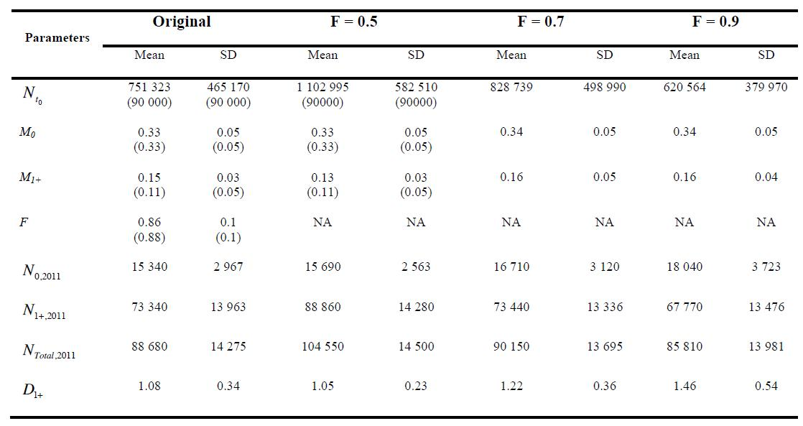

_

16 ICES Advice 2011, Book 3
Sources of information

ICES. 2006a. Report of the Joint ICES/NAFO Working Group on Harp and Hooded Seals, St. John’s, Newfoundland, Canada, 30 August–3 September 2005. ICES CM 2006/ACFM:6.

ICES. 2006b. Report of the Advisory Committee on Fishery Management, Advisory Committee on the Marine Environment and Advisory Committee on Ecosystems, 2006. ICES Advice, 2006, Book 3. 89 pp.

ICES. 2008a. Report of the ICES Advisory Committee, 2008. ICES Advice, 2008, Book 3. 106 pp.
ICES. 2008b. Report of the Working Group on Harp and Hooded Seals, 27–30 August 2008, Tromsø, Norway. ICES CM 2008/ACOM:17.

ICES. 2009. Report of the Working Group on Harp and Hooded Seals (WGHARP), 24–27 August 2009, Copenhagen, Denmark. ICES CM 2009 /ACOM:17.

ICES. 2011. Report of the Working Group on Harp and Hooded Seals, 15–19 August 2011, St Andrews, Scotland, UK. ICES CM 2011/ACOM:22.

ICES Advice 2011, Book 3 | 17

